PowMeter Shield for Nano

User's manual

Presentation of the shield 2
How to use PowMeter 3
Pluging the shield on the Nano board 3
Connecting the Shield 3
1) Without the special split cable 3
2) With the special USB split cable: 3
Limitations 4
PowMeter pinout 5
Display 7
“BOTH” layout 7
“USB” or “VIN” layout 7
Alert layout 7
Retrieving measurement values 8
Power modes 8
Calibrating the device 8
Examples of applications 9
1) Monitoring only the Nano USB power source 10
2) Monitoring only the Nano VIN power source 10
3) Monitoring the Nano USB power source and peripherals 10
4) Monitoring the Nano VIN power source + peripherals 11
5) Monitoring another circuit connected to the 5V pin and / or the VAUX pin 11
Programming and hacking the shield 12
I2C network 12
Download resources 12
Setting up PowMeter with a console program and retrieving measurement values 13
Calibrating the device 13
Defining the time lap between measurements 14
Displaying only USB or VIN values or both 14
Setting up a visual alert 14
Setting up a hardware alert 14
Retrieving values 15
Energy economy modes 15
Standalone use of the OLED 15
Modifying the shield’s program 15
Increasing USB current 16
Annex 18
Main specifications 18
Troubleshooting 20

Presentation of the shield

PowMeter Shield for Nano is an easy and versatile tool for monitoring your Arduino Nano projects.

The Shield is installed on the same place as the Nano board. It is only 26 millimetres longer.

It allows you to monitor USB voltage and current as well as the power consumption of the VIN MON pin.

VIN MON pin can source current to the VAUX pin, where you can connect the peripherals of your project, and also to the VIN pin when the jumper is ON.

It does not consume any of your project software resources thanks to the on shield MCU. It draws less then 10 mA.

All components are communicating through I2C. This means that you can take actions inside your own program depending on current or voltage values retrieved from the components.

You can configure the board using a console program loaded temporarily on the Nano board.

You can use the on shield OLED within your own project. The OLED can be rearranged on the other side of the board.

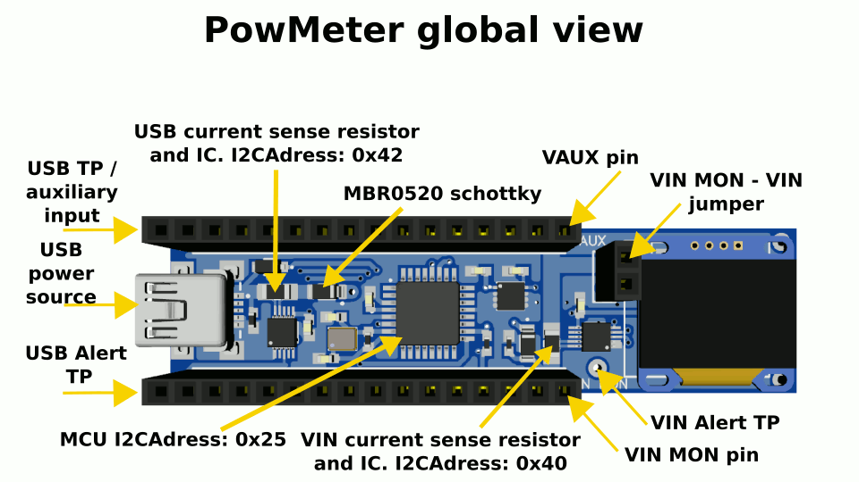

How to use PowMeter

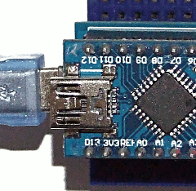
Plugging the shield on the Nano board

The shield has 2 * 16 pins. That is two more than the Nano Shield. Plug the Nano board above the Shield, aligned on the USB connector side. Do not power neither the board nor the shield before checking that all pins are properly connected.

When it is mounted on a Nano host, it can take a couple of seconds to start.

Connecting the Shield

1) Without the special split cable

Connect a USB A male to mini-B male cable (the usual Arduino Nano cable) between PowMeter and your computer.

PowMeter is not intended to program the Nano Shield. Since there is no way to access the USB data lines of the Nano board, you should use the Nano’s USB connector when you program it.

If you want to power the shield and program the Nano board at the same time, you can use the special split cable.

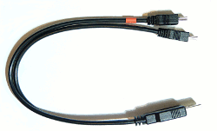
2) With the special USB split cable:

- Connect the regular UB mini B connector to PowMeter

- Connect the data only USB mini B connector (identified by the red ring) to the Nano host board

- Connect the USB A connector to your computer
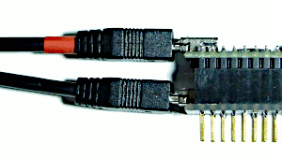

Avoid plugging the data only cable before powering the shield.

For a quick start, refer directly to Examples of applications

Limitations

Please note that in proper working order, the USB or VIN source might present a phantom potential even when not used. This is due to the Nano and shield power circuitry and is not a measurement error.

USB source

- The USB power source is not supposed to go higher than 5.25 volts with respect to USB specifications. But the power monitoring circuit on its own would support up to 24V / 800 mA (for example if you use it to monitor a circuit that supports higher specs).

- The current drawn from the USB is not supposed to be higher than 500 mA. If the current gets higher the shield’s schottky diode placed after the current sense resistor could burn. This would protect your USB power source. If it burns you can replace it with an MBR0520 diode (sod123 package). This is equivalent to the original Nano is power circuit. You can modify the shield to reach 800 mA or more (8A).

VIN MON source

- When the VIN MON – VIN jumper is OFF, VIN MON should not be exposed to more then 24 volts.

- When the VIN MON – VIN jumper is ON, the maximum voltage is around 13 volts due to the NANO voltage regulator capabilities.

- Risk of burning. PowMeter “Vin Mon” circuit is designed to handle a large amount of current and dissipate the heat, given its small size. Nevertheless, no more than 8 amps should pass continuously into the VIN MON pin. When measuring large currents and particularly above 6 amps check that the board is not overheating. The limitation comes from the temperature of the sense resistor and of the board. They can rise significantly when used to measure a strong current for a long period of time and depending on ventilation and ambient temperature. If needed, use proper ventilation. In case of over heating it is possible that the current regulator fails due to insufficient temperature headroom and has to be replaced.

PowMeter Power source

PowMeter is powered either by the USB power source or the VIN MON power source. It needs at least 4.5 volts on one of these sources.

PowMeter pinout

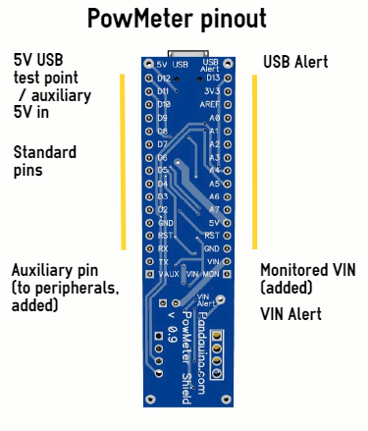

- The added “VIN MON” connector allows you to power the Nano board and / or the peripherals of your project with a supported auxiliary power source (usually 7 to 12 volts). On the top side of the board sits a jumper that connects VIN an VIN MON like this:

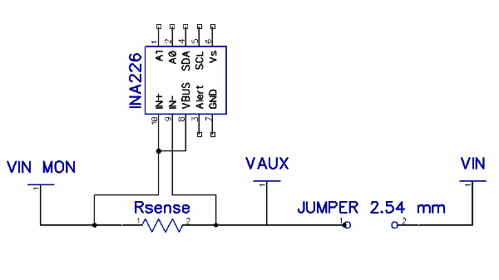

So, if you connect the jumper, VIN MON powers the VAUX pin and the VIN pin of the Nano, otherwise it only powers the VAUX pin.

- Connect your peripherals to VAUX if you want to power them from VIN MON or to the regular “5V” pin if you want to power them from the regular 5V rail.

- There is an extra tined hole labelled “5V SUB” next to the D13 pin. This is a test point directly connected to the 5V USB connector. You could use it if you would like to monitor another 5V source than USB. In this case you would solder a wire to this TP to emulate the 5V USB power source. Be aware not to connect the USB plug since you risk to inject current into your USB rail without any protection and use only a 5V source or you might burn the Nano.

- You can raise alert signals whenever USB or VIN voltage or current are out of a certain range. These signals are found on test points labelled “USB Alert” and “VIN Alert”.

Display

Depending on the configuration of the shield the display will be

“BOTH” layout

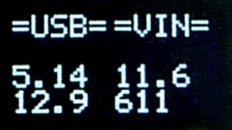
- The first column of the display shows the USB source properties, voltage above current.
- The second column displays the voltage above the current measured on the VIN MON circuit.
- Voltages are in volts.
- Currents are in mA.
- 3 or 4 digits are displayed.

“USB” or “VIN” layout

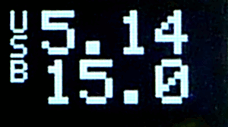
- The left column displays “USB” or “VIN”
- The second column displays the voltage above the current
- Voltages are in volts.
- Currents are in mA.
- 3 or 4 digits are displayed.

See “Displaying only USB or VIN values or both”

Alert layout

You can define USB and Vin minimum and maximum voltage and current values that will trigger a visual alert

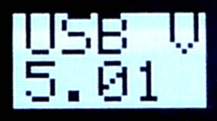
- Text is printed in black on white background
- The first line shows the type of alert: “USB V”, “USB I”, “VIN V” or “VIN I”.
- Then second line shows the value. Here we had set an alert triggered when USB Voltage is under 6V (unrealistic).

See “Setting up an alert”

Retrieving measurement values

You have the possibility to retrieve the last measurement values so you can use it within your own program.

See “Retrieving values”

Power modes

- In normal mode the shield consumes about 6.5 mA and measurement values are displayed on the OLED.

- But you can also turn off the OLED and retrieve values from your own program to reduce power consumption to 1.7 mA.

- And you can also turn off PowMeter when not needed and reduce the current drawn around 0.7 mA.

See “Energy economy modes”

Calibrating the device

It might be necessary to calibrate the device to measure currents of a few mA more precisely, since INA226A has a typical offset of +/- 2.5 uV.

Then proceed as explained in Scaling the device

Examples of applications

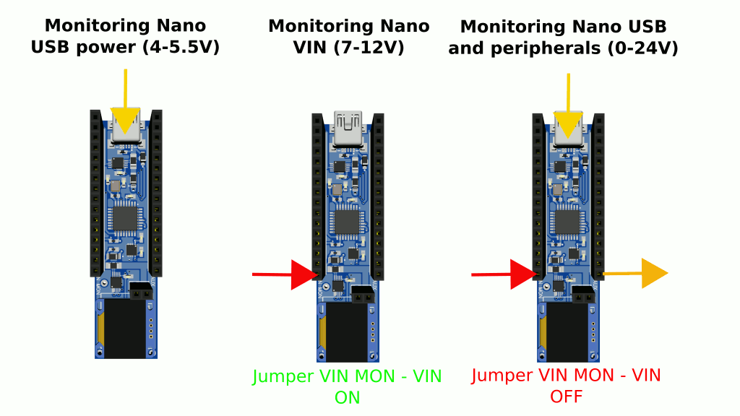

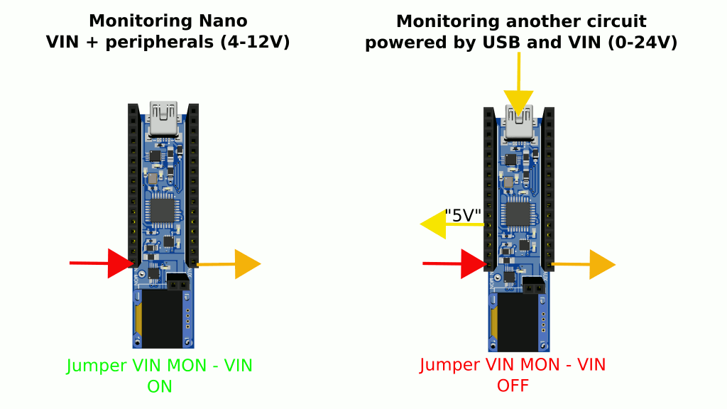

When monitoring peripherals powered at more than 12V, the jumper should be off since the Nano VIN power circuit max voltage is 12V in normal operation.

Monitoring only the Nano USB power source

  - Only the USB connector is connected to the Shield.
  - The jumper can be ON or OFF.

The display shows the USB voltage and current (here 5.14V, 15.0 mA).

Monitoring only the Nano VIN power source
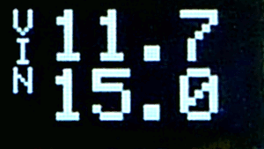
  - Only VIN MON is connected to a power source (7-12V)
  - The jumper is ON (if not, the Nano is not powered!)
  - Nothing is connected to VAUX

In this case the Nano board is powered through its VIN pin. The display shows the VIN MON characteristics (here 11.7V, 15 mA).

Monitoring the Nano USB power source and peripherals
  - USB is connected and will power the Nano
  - The jumper is OFF
  - VIN MON is supplied with the necessary source to power the peripherals (0-24V)
  - Peripherals are connected to VAUX

Do not supply more than 12V before removing the jumper!

The display shows separately the USB power consumption (here 5.14V, 12.9 mA) of the Nano board and the power consumption of the auxiliary circuit (here 11.6V, 611 mA).

    - Other peripherals could also be connected to the 5V pin and their consumption added to the “USB” characteristics. The total current on the USB should not exceed 500 mA.

Monitoring the Nano VIN power source + peripherals
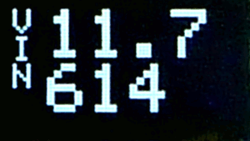
  - USB is not connected
  - The jumper is ON (if not, the Nano is not powered!)
  - VIN MON is supplied with the necessary source to power the Nano and peripherals (7-12V)
  - Peripherals are connected to VAUX

Do not supply more than 12V!

In this case the Nano board is powered through its VIN pin. The display shows only the VIN MON characteristics (= Nano + Peripherals current consumption, here 11.7V, 614 mA).

    - Other peripherals could also be connected to the 5V pin and their consumption added to the “VIN” characteristics.

Monitoring another circuit connected to the 5V pin and / or the VAUX pin

  - PowMeter is not plugged on the Nano board.
  - USB connector is connected to the Shield and / or VIN MON is supplied with the necessary source to power the peripherals (0-24V)
  - The jumper is OFF.
  - Some peripherals can be connected to the 5V pin if the USB is connected
  - Other peripherals can be connected to VAUX pin if VIN MON is supplied.

Depending on whether peripherals are drawing current on the 5V pin and the VAUX pin, the display is like in cases #1, #2 or #3

Programming and hacking the shield

I2C network

The shield is composed of 4 main components that are communicating through an I2C network:

- USB power meter IC (INA226) with an hexadecimal I2C address of 0x42
- VIN MON power meter IC (INA226) with an hexadecimal I2C address of 0x40
- OLED display with an hexadecimal I2C address of 0x3c
- Atmega328P with an hexadecimal I2C address of 0x25

This means that your program can communicate with any of these devices using the Wire or softWire library.

Download resources

You can download PowMeter source code, code examples and this manual from https://github.com/mrguen/PowMeter_Nano

Setting up PowMeter with a console program and retrieving measurement values

You can load a console program on your Nano board to set up PowMeter. It will send commands to the shield through I2C. The configuration you define will be saved in PowMeter’s EEPROM.

The console program example PowMeterNano_console_test.ino is included in the resources. It uses the source files:

- PowMeterNano_console.cpp,
- PowMeterNano_console.h
- PowMeterNano_typedefs.h

To set up any parameter your console program will send 1 command byte and 1 parameter byte.

If you are passing many I2C commands without delay between them, the I2C data might get corrupted or interrupts() might corrupt program variables and the result gets unreliable. Add some delays between I2C calls.

Calibrating the device

- To calibrate the USB measurement, plug the USB (@5V), place a multi-meter between the 5V pin and a load (approx 10 KOhm) connected to ground. Calculate the difference of current read on the multimeter and PowMeter.

- To calibrate the VIN measurement, power the VIN MON (@12V) place a multi-meter between the VAUX pin and a load (approx 1 KOhm) connected to ground. Calculate the difference of current read on the multimeter and PowMeter.

You might calibrate the device at the precise voltage you are using, instead of USB@5V or VIN@12V.

SET_USB_CURRENT_OFFSET and SET_VIN_CURRENT_OFFSET commands will shift the current reading with a negative or positive value.

A data byte (0 to 255) is sent as parameter. The value of the LSB is 0.01 mA. It is centred at 127.

USBCurrentOffset = (data - 127) / 100

Example, if you send the value “200”:
USBCurrentOffset = (200-127) / 100 = + 0.73 mA

Same for VINCurrentOffset

Defining the time lap between measurements

SET_PERIOD command will define the sleeping time of the Shield between measurements. You can choose any of these parameters values SLEEP_120MS, SLEEP_250MS, SLEEP_500MS, SLEEP_1S, SLEEP_2S, SLEEP_4S, SLEEP_8S

This period is the delay between two code loops. One loop last 40 to 150 ms that has to be added to the sleep period.

Displaying only USB or VIN values or both

SET_DISPLAY command will define the OLED layout depending on the parameter value “AUTO”, “USB”, “VIN” or “BOTH”

Setting up a visual alert

To define a visual alert you will have to set a voltage or current limit and activate the alert.

For example the command SET_USB_MIN_VOLTAGE with a parameter “45” will define 4.5V as the minimum voltage of the USB source under which an alert will be displayed and the USB Alert test point will go high.

To activate the alert mode on the USB power source you will have to use the command SET_USB_SOFT_ALERT followed by the parameter “TRUE”

After this a visual alert will be raised if any of the limits is beached.

Setting up a hardware alert

Hardware alerts are raised directly by INA chips. There can be only one alert active per channel (USB, VIN). Tests points “USB Alert” and “VIN Alert” are normally high (4.2V). If in alert they are near 0V.

To set up this alert you need to send a voltage or current limit for example with the command SET_USB_MAX_CURRENT followed by the parameter ‘100” to define a 100 mA current limit on the USB.

Then you will send a command “SET_USB_HARD_ALERT“ followed by the parameter “OVER_CURRENT”.

As long as the current is above 100 mA on the USB, the test point “USB Alert” will remain low.

Retrieving values

Commands GET_USB_VOLTAGE, GET_USB_CURRENT, GET_VIN_VOLTAGE and GET_VIN_CURRENT will return the appropriate values expressed in volts or mA.
A “dummy” parameter will be used.

Retrieving values from the shield’s MCU saves your program resources but you can also use a library (for example Arduino-INA226 ) to query values directly from the INA226 chips.

Energy economy modes

You can use the command SET_POWER to change the power consumption of PowMeter.

Parameters:

- “POWER_OFF” will put the shield in power down mode

- “POWER_ON” wakes up the shield

- “MEASUREMENT_HALT” does not trigger INA226 measurements but the consumption is that of normal mode

- “OLED_OFF” turns off OLED

- “OLED_ON” turns OLED back ON.

Standalone use of the OLED

The oled can display anything you would like. You would have to use an appropriate library. An example is given in the package.

Modifying the shield’s program

The shield’s program can be updated using an SPI programmer.

Wiring:

Please connect your SPI programmer (in 5V) to the shield pins like this

SPI adapter pin | PowMeter pin
1- MISO | D12
2 –VCC | 5V
3 - SCK | D13
4 - MOSI | D11
5 – RST | RST
6 – GND | GND

Software

Configure your programmer .

On the Arduino IDE, select

- type of Board: “Nano”
- processor: Atmega328 or Atmega328P depending on the chip implemented on the shield.
- the programmer you are using

Then you will upload the new code with the menu entry “Sketch” / “upload using programmer”.

The shield default’s program is made of the sketch PowMeterNano_uploading_firmware.ino that calls a library. It is included in the downloadable package.

Increasing USB current

USB current is limited by the schottky diode MBR0520 placed after the current sense resistor on the USB current measurement channel:

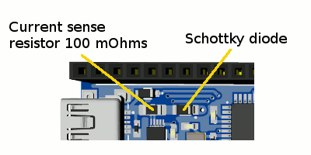

- Increasing current to 800 mA, with the same resolution:

The Schottky diode supports a constant current of 500 mA. You can replace it with a 1A diode in SOD-123 package. Your power source must withstand this current.

- Increasing to a couple of amps with reduced resolution:

If you want to measure higher currents the current sense resistor (1206 package) has to be replaced as well as the Schottky. And you will have to change the rsense value in the program. The resolution will change.

Max current (A) = 0.080 / current sense (Ohm)
Resolution (mA) = 0.0025 / current sense (Ohm)
Minimum power of the rsense = r*I^2 (W)

The heat dissipated also has to be evacuated by the shield. So the max current depends more on the heat dissipated than any other factor. You might use proper ventilation if needed.

Example with a 50 mOhm resistor:

Max current = 0.08 / 0.05 = 1.6A
Resolution = 0.0025 / 0.05 = 0.05 mA
Minimum power of rsense = 0.05*(1.6)^2 = 0.128 W. Better use a 0.25 W

Annex

Main specifications

- Voltage and current capabilities:

  - USB : Max 24V
0 - 500 mA (800 mA if shorting MBR0520 diode)
Current resolution: 0.025 mA

  - VIN : Max 24V
0 - 8 A
Current resolution: 0.25 mA

- Voltage resolution: 0.01V

- Measurement error : +/- 1%

- Display resolution: value < 1000: 3 digits, value >= 1000: 4 digits.

- USB voltage should be between 4.5 V and 5.5 V when used to power the Nano.

- VIN MON voltage should be between 7 V and ~13 V when used to power the Nano through VIN Mon – jumper -VIN pin

- There must be at least one source, USB or VIN MON, with voltage higher than 4.5V to power the shield.

- Current consumption of the shield:

To reduce power consumption the MCU is asleep between measurements. During MCU sleep periods in active mode the shield (i.e. 2 INA219 + OLED etc) consumes about 7 mA.

The MCU wakes up to make the measurement for a duration of about 40 ms. During this time period the current consumption has a small burst under 20 mA.

You can place the shield in POWER_OFF mode (see “Setting up PowMeter with the console program”). In this mode the MCU, the OLED and INA chips are shut down and PowMeter consumption falls around 700 uA.

If you would like to reduce further the POWER_OFF power consumption you could unsolder the 10 KOhm resistor placed on the upper left part of the board near the USB connector that acts as a USB rail pull-down. This will bring the power consumption around 200 uA.

You might do the same on the VIN line by removing the rightmost 10 KOhm resistor (VIN pull down).

Note that the current drawn on the high side of the shield, between the shield and Nano and on the low side of the Nano differ (if you compare with external multimeter readings at these 3 places of the circuit). The current consumption reported by PowMeter is that measured at the inputs of the Nano board and peripherals (i.e. between the shield and Nano).

- Burden

The burden on the USB line is 0.1 V / A + 1 diode MBR0520 voltage drop (same as in the internal Nano’s power circuit). Hence there is a difference between the USB voltage measured by the device and the “5V” rail voltage. This is done with respect to the original Nano power design. It is advised to power the Nano through VIN MON if it draws hundreds of mA and to power the peripherals independently (through VAUX for example).

The burden on the VIN MON line is 0.01 V / A.

Troubleshooting

- If the shield is not working properly, you can try first a hardware reset:
- Plug a wire in a ground pin and touch the other extremity on the top right pin of the Atmega328p = PC2 / physical pin n° 25 near the small capacitor.
- Turn off and on the power source to restart the shield.
- At start-up the OLED should display briefly the message “HARD RST”

- The OLED remains black

- Check that there is a power source with voltage higher than 4.5V either in the USB or on the VIN MON pin.

- Check that the voltage on pin 2 of the OLED is around 4.2V: if not the regulator situated at the top-right corner of the Atmega328p might be burnt. Normally the input voltage (4.3 to 24V) should be present on the upper left pad and 4.2V on the upper right pad of the DFN regulator.

- Check the resistance between pin 3 and 4 of the OLED. It should read between 5 and 20 KOhms.

- Load the program I2C scanner https://playground.arduino.cc/Main/I2cScanner/ on the host and check the I2C addresses of the components of the shield as reported in I2C network.

- Reload the firmware, see Modifying the shield’s program.

- The OLED is lit up but displayed text is corrupted or I2C commands sent from the host are raising errors

There might be other devices on the I2C network that are adding to the total capacitance of the bus. You can try to add soft pull-ups resistors between the OLED pin 2 (VCC=4.2V) and SCL (pin 3) and SDA (pin4).

